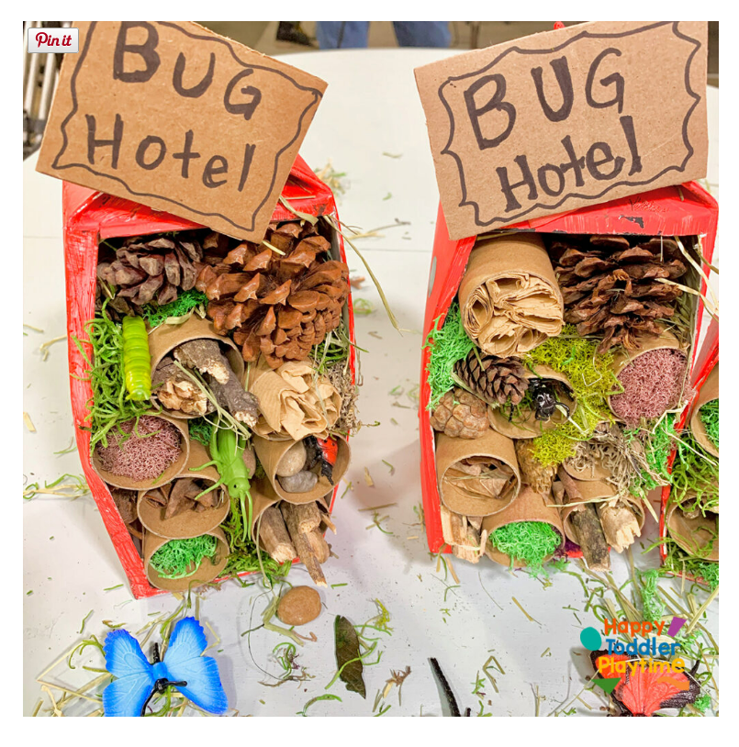
What makes a good bug habitat?
A well-built hotel can shelter anything from Hedgehogs to toads, solitary bees to bumblebees, and ladybirds to woodlice. You can build your bug hotel at any time of year, but you might have the most natural materials such as straw, dry grass and hollow plant stems in autumn.
A good bug hotel provides a variety of dry, protected nooks and crannies using natural and upcycled materials to attract diverse insects. It should be placed in a quiet, sheltered, and sunny spot, but with some shady areas, and be protected from rain and wind.

Task: Make a mini bug hotel to take home to put in your garden.
The hotel should be really tightly packed so that all the contents stay in place.
- Choose your hotel.
- Tie, wrap and pack as many different materials as you can into your bug hotel.
- Use a sticker to put your name / make a sign for your hotel.
- When you take it home, find a dry, sheltered spot outside to put your bug hotel.

