

BPS Forest School: P6-1A
Session Title: | Location: |  | Curriculum / Topic Link:
Art Gallery | Six Mile Water River Park, Ballyclare |  | Numeracy – Number
KS2 NI Statutory Requirements: | Learning Intentions: |  | Resources:
Pupils should be enabled to:  - Know the multiplication facts up to 10x10;  - Engage in a range of activities to develop understanding of the four operations of Number.  Processes:  - Understand mathematical language and use it to discuss their work and explain their thinking. | Children are learning to:  - Apply their multiplication table facts up to 10x10 to create art from natural materials.  - Find the sum of three numbers  - Explain their calculation methods both orally and in written form |  | - Selection of natural materials from Forest School area e.g., sticks, stones and pinecones  - Laminated images of the work of a famous artist e.g., Andy Goldworthy  - iPad/cameras (optional)  - Laminated A3 sheets of paper as blank canvas for artwork (optional)  - Chalk or whiteboards for written calculations
Lesson Activities:
Pre-lesson preparation
- Gather resources and check Forest School site for any potential hazards prior to bringing children for lesson.

Introduction
- As a group, establish Forest School rules / site boundaries and outline purpose of ‘base area’.
- Discuss what the children already know about an art gallery. Have you ever visited an art gallery? Where did you go? What did you see? What is the purpose of an art gallery?
- Discuss images of the work of a famous artist such as Andy Goldsworthy. What is the same about each picture? What is different? What shapes can you see? What patterns can you see? What materials has he used? What might you use to create a similar effect?

Main Session  - Explain that children will work in groups of two or three to create their own pictures for display in the outdoor ‘Forest School Art Gallery’. They will use natural resources to create a picture and then determine the value of it.  - To begin with, use three different natural resources (such as sticks, stones and pinecones) and limit the number of each to a maximum of ten. Assign values to each resource: sticks (10), stones (5) and pinecones (2). This will restrict the multiplication challenge to multiplication facts up to 10 × 10.  - Model to the children how to create and calculate the value of a piece of art.  - Children will work in small groups (could later be extended to individual task) to collect natural materials from the Forest School area to create their picture.  - Once the pictures are complete, each group should then calculate the value of their picture and record it using chalk (if appropriate) or on their whiteboards brought from the classroom. Encourage the children to show their working out.  - Children should photograph their artwork and working out calculations for display purposes back in the classroom and as evidence to be uploaded to pupil’s online Seesaw learning journal. |  | Adult Roles:
- Encourage independence, working with a partner or a team for support.
- Move around and assist each group where required and ask groups to explain their picture, choice of materials and calculation methods.
- Check if the children can recall table facts within 10x10; calculate the total of 3 numbers using mental or written methods; record their calculations clearly; explain their thinking using mathematical language.
- Where necessary, model elements of the task yourself, acknowledging the tricky parts and being positive about the management of difficulties.
Plenary
- As a class, take time to walk around the ‘Forest School Art Gallery’ to view the exhibits. Invite each group to share their creative work with their peers for constructive feedback. Draw attention to the different methods used to calculate the value of their pictures. Encourage pupils to use appropriate mathematical language when explain their methods.
- Ask questions which focus on their understanding of number and place value such as: Which picture is the most / least expensive? How do you know? Which pictures cost more / less than £100? How do you know? Which pictures could I afford if I have £250 to spend? What change will I get from £120 if I buy this picture? What happens to the value of the picture if I add…(one more stick/stone etc.)?
- Praise, celebrate and photograph examples of good work.
- Key questions: What went well? Why? What didn’t go as well as expected? What could be changed? Who stood out? Why?
- Evaluate the lesson using the Forest School faces. Choose someone from each group to say what they liked/disliked.
- Tidy up the Forest School site and remind the children of the ‘Leave No Trace’ motto of Forest School.

Further Information /Links:
- Children could order the pictures from the most to least expensive.
- Children could explore the work of other famous artists / sculptors.
- This activity could be adapted for different multiplication table facts by assigning different values to the sticks, stones etc.
- This activity could also be adapted to explore decimal fractions. For example, sticks could represent tens, stones could represent ones, leaves could represent tenths and pinecones could represent hundredths.
Lesson sourced from Stranmillis University College ‘Out and About’ outdoor activities for KS2 Maths
https://www.stran.ac.uk/wp-content/uploads/2024/02/Art-Gallery-Number-and-Algebra.pdf
Examples of natural art pieces by Andy Goldsworthy:
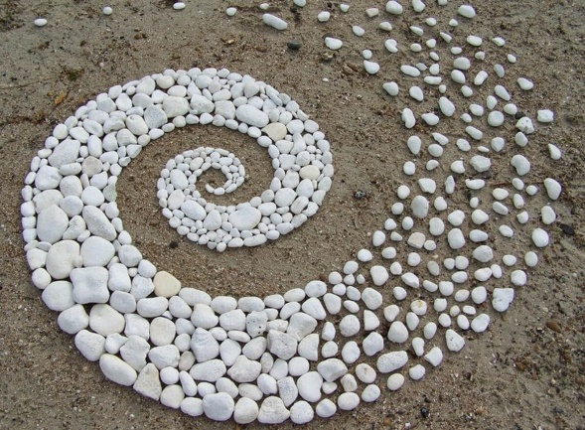
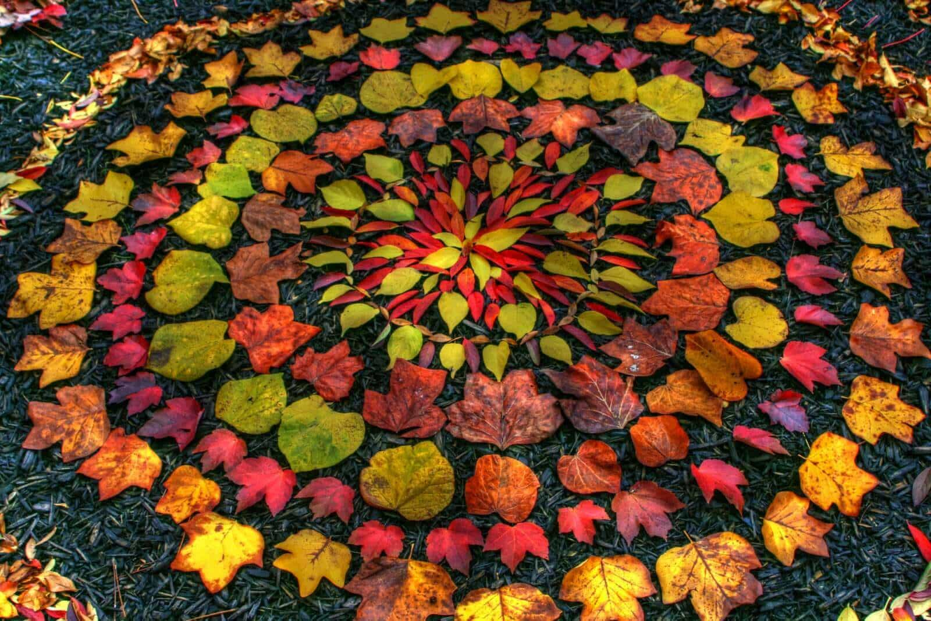

Examples of children’s art inspired by Andy Goldsworthy:
