

BPS Forest School: P5-1B
Session Title: | Location: |  | Curriculum / Topic Link:
Stone Age Shelters | Six Mile Water River Park, Ballyclare |  | WAU – Early Man (H)
KS2 NI Statutory Requirements: | Learning Intentions: |  | Resources:
Pupils should be enabled to explore:  - The effect of people on the natural and built environment over time (I).  - How place influences the nature of life (P).  - Ways in which people, plants and animals depend on the features and materials in places and how they adapt to their environment (P). | Children are learning:  - To create a Stone Age shelter/den in the Forest School Area using natural materials.  - How people and places have changed over time (H).  - Similarities and differences in people’s lives past and present (H). |  | - Selection of natural materials from Forest School area  - Bamboo canes  - Cord, string, wool or twine  - Tarpaulin sheets  - Pegs (to attach tarpaulin if needed)  - iPad/cameras (optional)  - Paper/clipboards (optional)
Lesson Activities:
Pre-lesson preparation
- Gather resources and check Forest School site for any potential hazards prior to bringing children for lesson.
- Ensure children have completed lessons on ‘Early Homes’ back in class and are familiar with the type names / features.

Introduction
- Recap Forest School rules, boundaries of site and ‘base area’ purpose.
- Ask the children to imagine we are travelling back in time to the Stone Age era when the first settlers arrived in Ireland in around 7000BC. Ask the children to use their topic knowledge so far and come up with questions they would like to answer about that era – this could be a think/pair/share activity.

Main Session  - Ask the children if they could describe how Early Man (Mesolithic people) used to live. Focus on hunting and gathering lifestyle, use of flint for weapons/tools, settlements, location, shelter types etc.  - Explain to the children that today the class are going to become ‘Nomads’. Early people who did not settle in one area but moved from place to place in search of food. They quickly built their shelters/houses from sticks covered with animal skins. Today the children will be working in groups of 4 or 5 to create a Stone Age era shelter using bamboo canes and other natural materials from the Forest School area – they will not be using animal skins however!  - Ask the groups to look around and chose a suitable site for their shelter within the boundary of the Forest School area.  - Groups will then collect natural materials, wool/twine, pegs, tarpaulin and bamboo canes to begin constructing their shelter.  - Children may choose to include decorations in their shelter such as daisy chains, objects hung from string inside or outside their shelter etc.  - Optional extra: children could use paper / clipboards to draw a diagram of their shelter, complete with appropriate labels and notes. |  | Adult Roles:
- Encourage independence, working with a partner or a team for support.
- Where necessary, model elements of the shelter building task yourself, acknowledging the tricky parts and being positive about the management of difficulties.
- Ask the children to explain their choice of site/shelter type/structure.
- Allow experimentation but consider safety.
- Ensure that shelters are structurally sound before entering.
- Staff or children should photograph completed shelters for classroom display purposes and as evidence to be uploaded to pupil’s online Seesaw learning journal.
Plenary
- As a class, take time to walk around the Forest School area to view the different shelters the pupils have constructed. Invite groups to share their shelters with their peers for constructive feedback. Draw attention to the different methods of construction used and different types of shelters created e.g. ‘lean to’, ‘teepee’, ‘frame’ shelter etc. Encourage pupils to use appropriate language when explaining their shelter’s structure e.g. ‘uprights’, ‘ridge pole’, ‘ribs’ etc.
- Describe and discuss the effectiveness of the shelters. Identify the pros/cons of each. Did any fit their whole team inside?
- Praise, celebrate and photograph examples of good work.
- Key questions: What went well? Why? What didn’t go as well as expected? What could be changed? Who stood out? Why?
- Evaluate the lesson using the Forest School faces. Choose someone from each group to say what they liked/disliked.
- Tidy up the Forest School site and remind the children of the ‘Leave No Trace’ motto of Forest School.

Further Information /Links:
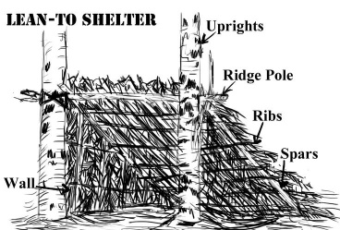
- Extend the lesson further by making a ‘Stone Aged Stewed Fruit’ – see recipe card overleaf.
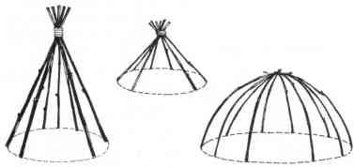
- Examples of Early Man shelters for reference:
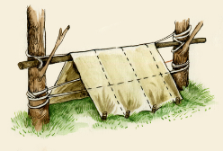
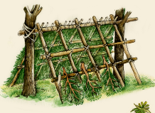
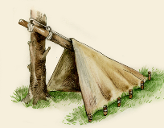

Real life examples:
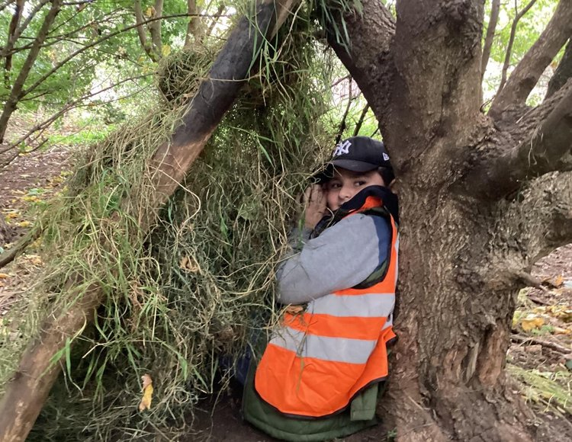
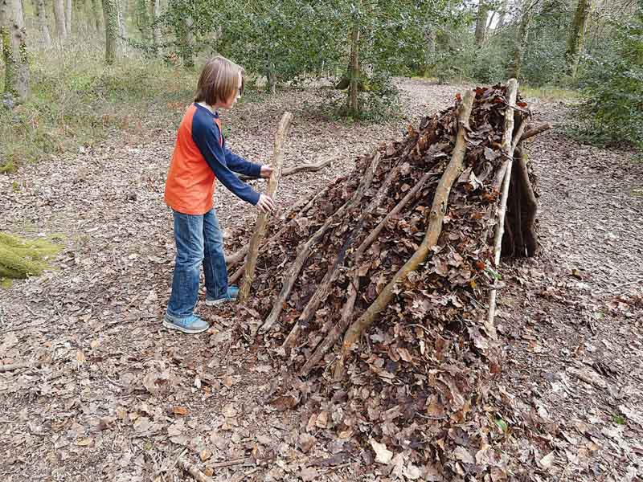

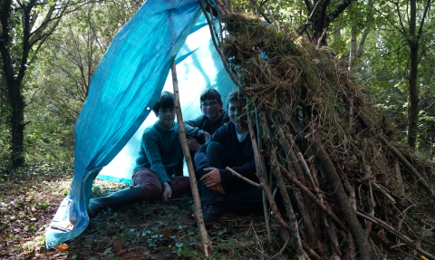
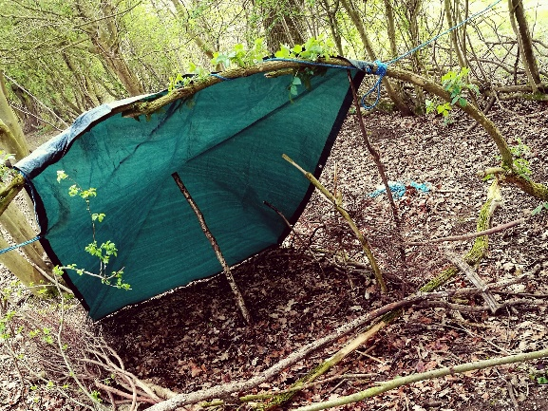

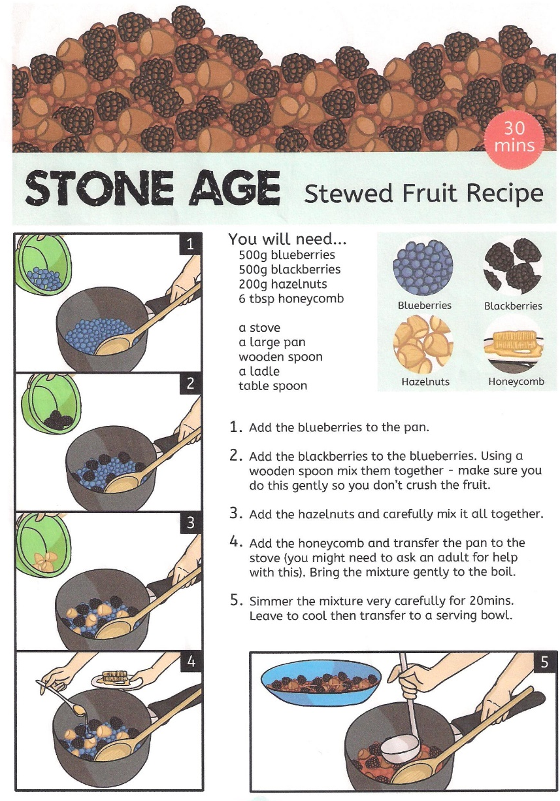
Stewed Fruit recipe:

