

BPS Forest School: P5-1A
Session Title: | Location: |  | Curriculum / Topic Link:
Map Making | Six Mile Water River Park, Ballyclare |  | WAU – It’s a Small World (G)
KS2 NI Statutory Requirements: | Learning Intentions: |  | Resources:
Pupils should be enabled to:  - Explore features of, and variations in places, including physical, human, climatic, vegetation and animal life.  - Explore their place in the universe  - Use coordinates in the first quadrant | Children are learning to:  - Create a map of the Forest School Area using natural materials  - Identify their location on a map  - Use a map to identify where others are and to find the location of an object |  | - Bamboo canes to frame maps  - Selection of natural materials from Forest School area  - Example of a map to aid discussion  - Six Mile Water Park maps  - iPad/cameras (optional)  - ‘Treasure’ to hide
Lesson Activities:
Pre-lesson preparation
- Gather resources and check Forest School site for any potential hazards prior to bringing children for lesson.

Introduction
- As a group, establish Forest School rules / site boundaries and outline purpose of ‘base area’.
- Ask the children: How familiar are they with the Forest School area? Can they identify, name and describe human and physical geographical features in the learning area e.g. grassed area, parking areas, play areas, tarmac areas, walls, hills etc.? Could they confidently describe the setting to a partner?
- Warm up game - Cars: A blind trust game (in pairs): Each child takes it in turn to be either the ‘driver’ with an imaginary steering wheel but with their eyes closed or the ‘backseat driver’ who has their eyes open and their hands on the driver’s shoulders. The driver controls the speed, but the backseat driver controls where they go, keeping them both safe and describing what they can see (geographical features) as they travel around the learning area.
- Gather children together to discuss whether the descriptions were accurate, whether they felt safe and what could have been done to make it an even better experience. Did they learn something new about the area?

Main Session  - Show pupils an example of a map. Discussion questions before beginning task: What is a map? What viewpoint is a map taken from? Why would a map be useful? How could you locate yourself on a map? What size does a map need to be? (some pupils may be aware of ‘scale’ on a map). How can we tell what things are on a map? What is a key? Do you know any map symbols e.g. bridge?  - Explain that today the children will be working in groups of 3 or 4 to construct a map or a ‘birds’ eye’/’aerial’ view of the Forest School area from natural materials such as twigs, leaves, stones etc. The bamboo canes will form a frame for each group’s map. The maps should identify lots of the human and physical geographical features that were discovered in the introductory game. Maps could show outlines of areas bordering the Forest School area for context.  - Ask the groups to look around and chose a suitable site for their map within the boundary of the Forest School area.  - Groups will collect bamboo canes to frame their map and begin gathering natural materials to construct their map. Children may wish to move around while creating their map to ensure accuracy/check distances between features.  - Regroup pupils and ask them to place an item onto their map that identifies their location. Explain that ‘map orientation’ is where a map is orientated to features on the ground.  - Treasure Hunt game - Give each group an item (treasure) to hide in the Forest School area. Groups must then place an ‘X’ on their map where it is hidden and challenge another group to read the map and find the treasure! |  | Adult Roles:
- Encourage independence, working with a partner or a team for support.
- Move around and assist each group where required and ask groups to explain/describe their map, choice of materials to represent different geographical features, if they have considered any kind of ‘scale’ for their map, can they locate themselves etc.
- Where necessary, model elements of the map making task yourself, acknowledging the tricky parts and being positive about the management of difficulties.
- Staff or children should photograph completed maps for classroom display purposes and as evidence to be uploaded to pupil’s online Seesaw learning journal.
Plenary
- As a class, take time to walk around the Forest School area to view the different maps. Invite groups to share their creative work with their peers for constructive feedback. Draw attention to the different methods used to identify the geographical features. Encourage pupils to use appropriate geographical language when explaining their map e.g. ‘human’ and ‘physical’.
- Describe and discuss the effectiveness of the maps. Identify the pros/cons of each. Did any add in grid lines/north arrow?
- Praise, celebrate and photograph examples of good work.
- Key questions: What went well? Why? What didn’t go as well as expected? What could be changed? Who stood out? Why?
- Evaluate the lesson using the Forest School faces. Choose someone from each group to say what they liked/disliked.
- Tidy up the Forest School site and remind the children of the ‘Leave No Trace’ motto of Forest School.

Further Information /Links:
- Extend the lesson further by giving pupils additional bamboo canes for grid lines and to add in a north arrow.
- Ask the children to identify the coordinates of some of the features on their maps. Pupils could then quiz other groups who come to view their completed maps.
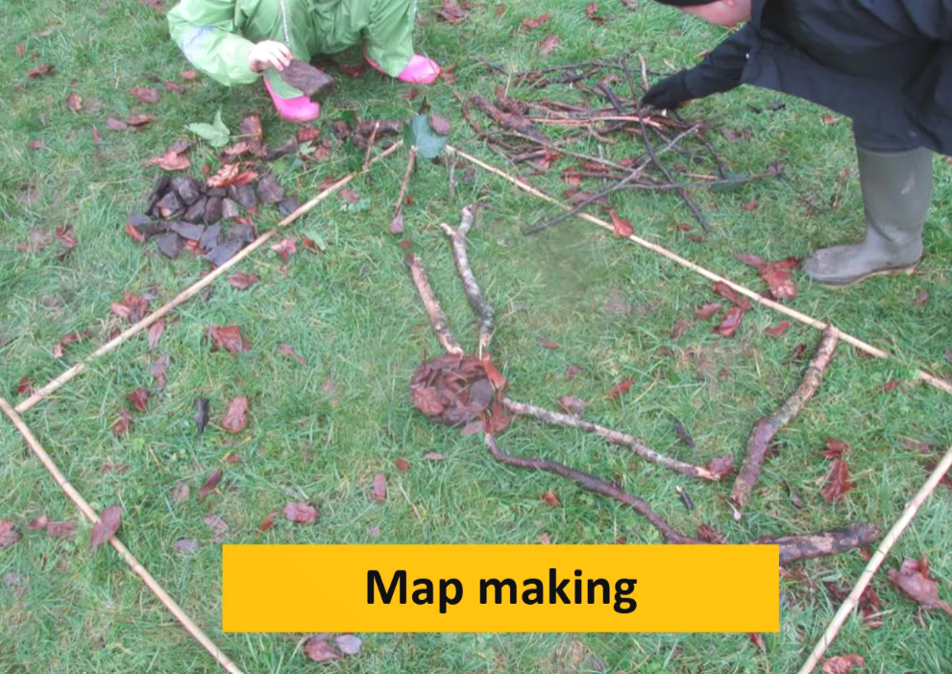
Example of ‘Map Making’ task in action:

