Planting Time: Spring | Friday 14th March 2025
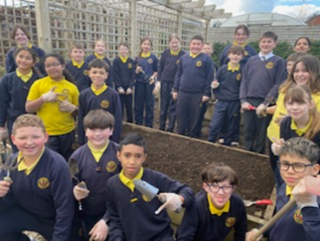 | - Last year’s P7 pupils planted two different varieties of potato seeds in our Garden to Grow: Golden Wonder and Kerr’s Pinks.
Harvest Time: Autumn | Wednesday 1st October 2025
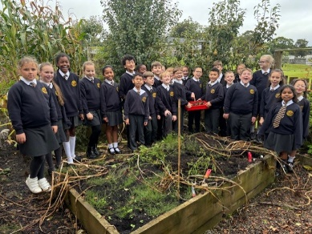 | - We used a trowel to dig up two potato plants. The stalks were wilted and had fallen over but underneath the soil we found 29 beautiful spuds! They were all different sizes…1 was nearly the size of our heads while another was as small as a marble!
Cooking Time: Autumn | Thursday 2nd October
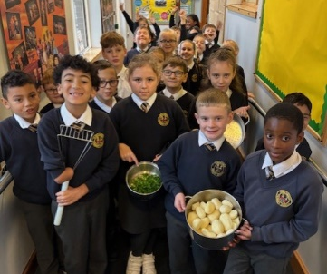 | 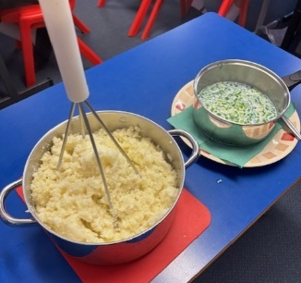 | 
- We washed and peeled the potatoes before steaming them over a pot of boiling water.  - We chopped the scallions and put them in a pot of milk to infuse. | - We used a big potato masher to mash the potatoes.  - We added the milk and scallions to make a thick creamy champ.  - We added a pinch of salt and a knob of butter. | - The delicious scallion champ was now ready to enjoy.  - P5 pupils tucked in with a spoon and most people absolutely loved it!  DELICIOUS!

