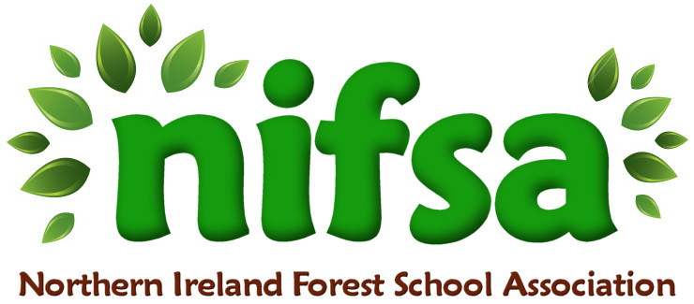
NIFSA Lesson Plan Template

Planning
Location | School field (outdoor classroom area)
Date | September 2025
Class | Nursery
Classroom Management | Members of staff: Miss Hanna (teacher), Mrs Bacon (general assistant), Miss Morrow (SEN support assistant for J) Miss McBride (SEN support for JON)
Connected Learning/Prior Knowledge | We have been reading books about colours and talking about our favourite colours.
Resources needed | Boundary sticks, whistle, trays
Health and Safety | Site and activities fully risk-assessed.
Emergency equipment | First Aid kit

Lesson Content
On Arrival | Welcome everyone  -Practice whistle (2 for freeze, 1 come to me)  -SONG- I can sing a rainbow  -Colour Game. Distribute coloured cards throughout area. Call out a colour and children must run and find the colour as quickly as possible.
Activity explained | Each staff member will take a group of children on a colour hunt of the school grounds. This will be lead by the children and the staff member will take photographs on the Ipad
Finishing | We will look at the pictures of the colour hunt on the interactive whiteboard. Each group will present their findings.

Evaluation/Review
How did the group session go?
Focus on individual pupils
What would you change for next time?

