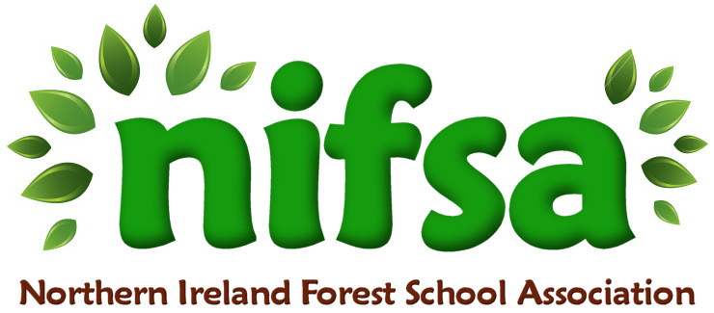
NIFSA Lesson Plan Template

Planning
Location | School field (outdoor classroom area)
Date | January 2026
Class | Nursery
Classroom Management | Members of staff: Miss Hanna (teacher), Miss Milliken (general assistant) Miss McBride (SEN assistant) Harley (NRC student)
Connected Learning/Prior Knowledge | Children have prior experience of outdoor play and Forest School routines, including boundary rules, listening for the whistle, and exploring natural materials. Previous learning includes sensory play with natural objects (leaves, sticks, stones) and discussions about seasonal changes, particularly winter and cold weather. Some children have explored water and ice during indoor sensory play.
Resources needed | Boundary sticks, whistle, flower petals, water, bowls, sticks/wool
Health and Safety | Site and activities fully risk-assessed.
Emergency equipment | First Aid kit

Lesson Content
On Arrival | - Children gather at the meeting point within the boundary area  - Welcome circle and reminder of Forest School rules (kind hands, listening ears, staying within boundaries)  - Brief discussion about winter and cold weather  - Introduce today’s activity: collecting nature to make “nature wands” that will be frozen
Activity explained | - Adults model how to carefully collect natural materials from the ground (not pulling from living plants)  - Children explore the area and choose items they like  - Natural materials placed into bowls  - Children help pour water into bowls with adult support  - Sticks or wool added to create wand handles  - Adults explain that the bowls will be frozen overnight and explored in a future session  Key language modelled: cold, freeze, ice, nature, water, bowl, collect, winter
Finishing | - Children return to the circle area  - Brief recap: What did we collect? What do you think will happen to the water?  - Bowls collected safely by staff  - Calm transition back indoors with handwashing routine

Evaluation/Review
How did the group session go?
Focus on individual pupils
What would you change for next time?

