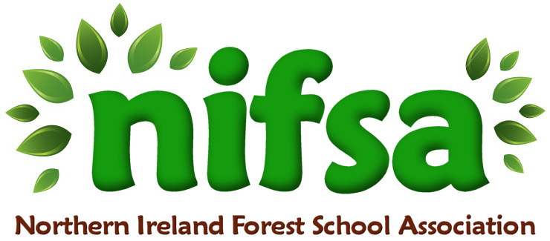
NIFSA Lesson Plan Template

Planning
Location | School field (outdoor classroom area)
Date | 22.9.25
Class | Primary 7
Classroom Management | Teacher  SEN assistant
Connected Learning/Prior Knowledge | P7 topic is “Vikings”  Previous lesson Viking longhouses
Health and Safety | Site and activities fully risk-assessed. All adults briefed on safety and children briefed on behaviour expectations
Emergency equipment | First Aid kit
Resources | Whistle, Small flat stones/bark, chalk/charcoal, printed rune alphabet.

Lesson Content
On Arrival | 1. Introduction & Hook (5 mins)  - Gather the children in a circle outdoors. Boundaries  - Briefly explain: Vikings used runes instead of our alphabet. Each symbol had both a sound and often a meaning (e.g., “ᚠ” stood for F and symbolised wealth).  - Show the rune alphabet (poster or one printed sheet) and highlight a few interesting ones.  - Question prompt: “Why do you think Vikings carved their writing into wood or stone instead of paper?”
Activity explained | 2. Rune Hunt & Materials Collection (5 mins)  - Split into 5 groups of 6 children (1 adult floats between groups).  - Each group gathers natural materials (sticks, stones, leaves) to use as “rune builders.”  - Set boundaries for safe collection.  3. Rune Challenges (15 mins)  Rotate through short tasks:  Task 1 – Name in Runes  Each child spells their name (or initials) using natural materials to form runes.  Task 2 – Secret Messages  In pairs, children create a 1–2 word message (e.g., “friendship,” “Vikings,” “North”). Another pair must decode it using the rune chart.
Finishing | 4. Sharing & Reflection (10 mins)  - Gather together to look at some names/messages.  - Invite groups to decode each other’s rune words.  - Reflect: “What was tricky about using runes compared to our alphabet?”  - Link to Viking life: carving runes was time-consuming, often used for special purposes (memorial stones, charms, ownership).

Evaluation/Review
How did the group session go?
Focus on individual pupils
What would you change for next time?

