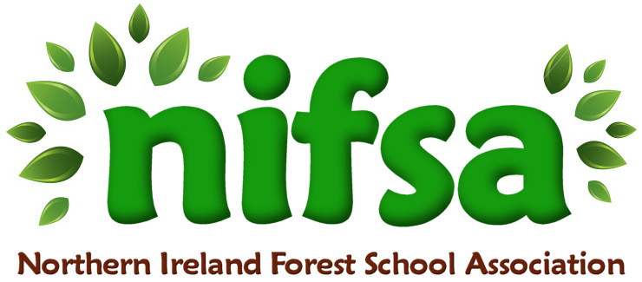
NIFSA Lesson Plan Template

Planning
Location | School field (outdoor classroom area)
Date | 15.9.25
Class | Primary 7
Classroom Management | Teacher  SEN assistant
Connected Learning/Prior Knowledge | P7 topic is “Vikings”  Previous lesson Viking ruins
Health and Safety | Site and activities fully risk-assessed. All adults briefed on safety and children briefed on behaviour expectations
Emergency equipment | First Aid kit
Resources | Whistle, Sticks, logs, leaves, coats/tarps, toy figure for scale.

Lesson Content
On Arrival | Welcome everyone- safety brief  1 whistle to freeze, 2 whistles to move on  Intro (5 mins): Show image of Viking longhouse. Discuss: Why were they long and narrow? What materials did Vikings use?
Activity explained | Activity (25 mins):  - Groups use natural materials to build mini Viking longhouses around their “ruins” from Lesson 1.  - Must include a “hearth” (stone circle).  - Optional: fit toy figure inside.
Finishing | Plenary (10 mins):  - Tour each structure.  - Questions: What makes a strong house? What was tricky?  - Link to importance of timber, turf, and settlement sites.  Game:  Viking ship races  This game is a great way to get children engaged in learning about Viking culture and history. It requires two teams of players, each with their own “ship” (a large blanket or tarp). The goal is for the teams to race across the area while staying on their ship. To make it more challenging, you can add obstacles such as chairs or hula hoops that they must navigate around. Can they work as a team to cross the ocean?

Evaluation/Review
How did the group session go?
Focus on individual pupils
What would you change for next time?

