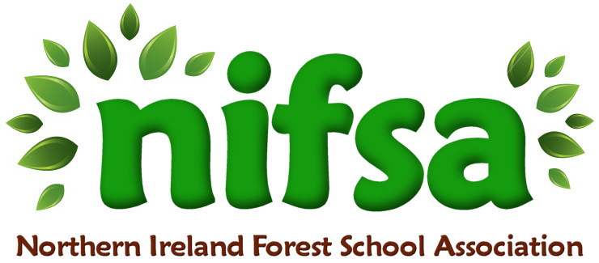
NIFSA Lesson Plan Template

Planning
Location | School field (outdoor classroom area)
Date | 21/11/25
Class | Nursery
Classroom Management | Whole class- each child will have a parent/carer with them  Members of staff: Miss Hanna, Miss Milliken, Miss Morrow (SEN support assistant for Daisy) Rhiannon (Level 2 student), Heather Quiery (volunteer)  Blow whistle once to freeze and tidy up- two whistles to move on
Connected Learning/Prior Knowledge | Children have been learning about the seasonal changes of autumn; changing colours of leaves, hedgehogs preparing to hibernate and birds migrating south for winter. Children have had practice hammering using different types of hammers (on ice, pumpkins). Children have a growing awareness of safety and risk.
Health and Safety | Site and activities fully risk-assessed. All adults briefed on safety and children briefed on “stop, drop and roll” in case of fire.
Emergency equipment | Watering can, plunge bucket (trug of cold water), first aid kit

Lesson Content
On Arrival | Welcome everyone- safety brief  1 whistle to freeze, 2 whistles to move on
Activity explained | - Bird feeders- Pipe cleaners, cheerios (thread cheerios on to the pipe cleaner and make a hook at the top)  - Obstacle course- planks, tyres, crates  - Stick towers/Teepees- sticks  - Nail hedgehogs- balsa wood, hammers, nails  - Campfire- firelighters, kindling, lighter, tongs, marshmallows, bamboo sticks
Finishing | Bring everyone together to tidy up- close session  Leave no trace

Evaluation/Review
How did the group session go?
Focus on individual pupils
What would you change for next time?

