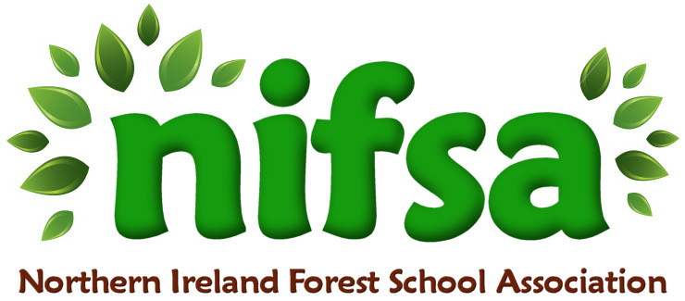
NIFSA Lesson Plan Template

Planning
Location | Horizon Surestart Garden
Date | 21/10/25
Class | 12 children who ever wants to join in
Classroom Management | Whole class involved
Connected Learning/Prior Knowledge | Knowing how to blow bubbles, learning about the weather, wind blowing and direction of the wind.
Health and Safety | Complete risk assessment beforehand, makesure there are the correct ratios, supervise at all times.
Learning Intention | To apply the right amount if bubble mixture and the right amount of force to blow a bubble.
Success Criteria | To have fun and blow bubbles
Resources | Elder hollowed out, bubble mixture, tray for dipping
Differentiation/Target Groups | Some children can do activity independently and others will need support with sharing and taking turns
Other

Lesson Content
On Arrival | On arrival blow the wistle, get the children to set the boundaries, discuss activity, show the children an example and show resources, demonstrate what we are doing and discuss why.
Activity explained | We used elder branches/twigs to blow bubbles
Finishing | Popped all the bubbles then went to free play again.

Evaluation/Review
How did the group session go? | Elder bubble, using elder branches/twigs to blow bubbles.  Learning opportunity:-  Physical:- developing grip, and developing oral muscles  Language and communication:- talking about the bubbles, colours and popping and flying etc  Personal, social and emotional:- learning turn taking, cooperating one person blowing and another popping and then swapping.  Exploring and thinking:- learning about force and how much liquid to use to make a successful bubble, testing each time.  I feel this worked well, children enjoyed it.
Focus on individual pupils | One child sucked the bubble mixture instead of blowing, but then learnt from his mistake and blew instead
What would you change for next time? | I would have more containers to share out.

