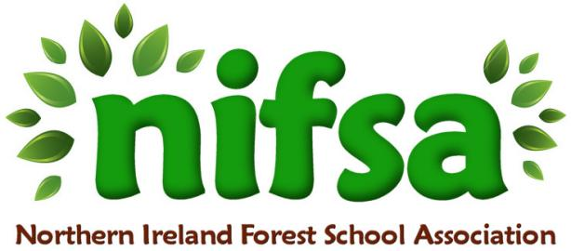
NIFSA Lesson Plan Christmas

Planning
Location | Ballysally wildlife garden
Date | 17th December 2025
Class | P5
Classroom Management | whole class
Connected Learning/Prior Knowledge | Previous experience from whittling and making their own characters.
Health and Safety | Risk assess the area before the session.  -Low-hanging branches.  -Slippery surfaces.  -prickly or stinging plant’s  -Remind children of the rules that are there to keep them safe.  -First Aid Kit  -Any children’s medication e.g. inhalers
Learning Intention | To use natural materials in the wildlife garden to create their very own Christmas tree and decorations.
Success Criteria
Resources | sticks/twigs that have fallen on the ground.  twine  elf  stocking  different coloured paper  scissors  note from the elf
Differentiation/Target Groups | lower achievers to feel empowered to use their imagination to create a Christmas tree/decoration, to also help develop their fine motor skills. cutting, tying and wrapping twine.  For all to be able to work in a team and respect each other.  Higher achievers to extend on their own learning and creativity. To also be able to problem solve how to make a Christmas tree.
Other

Lesson Content
On Arrival | On arrival to have hidden a stocking with an elf sitting inside. With twine hidden inside and a note with the elf asking if they could make him a Christmas tree and decorations.  Remind the pupils of the rules and boundaries.
Activity explained | Explain to the children that something feels different in the Ballysally wildlife garden. What could it be?  Get the children to go and search the garden to see what it could be. Ask them what it is?  Once the pupils have located the stocking, get one of the children to lift down the stocking and read the note.  Then the children will need to be split into groups to either help build the Christmas Tree or make their own decoration. Using the natural materials in the garden and also the twine provided. remind them to not break any branches but to use anything that has fallen naturally.
Finishing | Come together at the end and have a look at what the children have created. Are they happy, sad etc. do you think the elf is happy?  Maybe we could all sing ‘we wish you a Merry Christmas ‘

Evaluation/Review
How did the group session go? | The session went ok. The children showed a lot of enthusiasm. They also discovered lots of things in the wildlife garden. They were also frustrated at certain parts.
Focus on individual pupils | e.g. Pupil A worked very well as part of a team  Sariya found a leaf that had spiky veins under the leaf. (bramble).  Jace found sap from a tree that was sticky when climbing it. A few of the children (Annie) were frustrated that they couldn’t tie a knot when making the Christmas tree. They all tried their best.
What would you change for next time? | Most of the children felt slightly disappointed at the end of the session because it didn’t go the way they liked.  I would help them to work on basic skills, e.g, how to tie a basic knot. Also to give them more free time. to see what they natural discover. Wear waterproof trousers.

Hello!
Thank you for finding me!
I was getting lonely up there.
Can you see what is inside my stocking?
Could you use it to make me a Christmas tree from the sticks you can find in your wildlife garden. I would really like to see some decorations too.
Remember don’t break any branches of the trees.
I can’t wait to see what you can create!
Merry Christmas Everybody!

