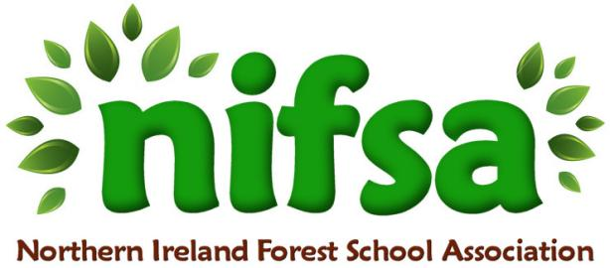
NIFSA Lesson Plan 3

Planning
Location | Ballysally wildlife garden
Date | 23.1.26
Class | P3/4
Classroom Management | e.g. whole class  small group of 9/10 children with me (Suzanne) and Catherine.
Connected Learning/Prior Knowledge | e.g. prior knowledge about camouflage needed  Following on from when the children made secret hideouts, the children started to make little campfires by their secret hideouts.
Health and Safety | Risk assess the area before the session.  -Low-hanging branches.  -Slippery surfaces.  -prickly or stinging plants (nettles).  -Remind children of the rules that are there to keep them safe.  -First Aid Kit  -Any children’s medication e.g. inhalers  Fire Safety check!  buckets of water  create fire circle  identify ‘safe’ and ‘no-go’ areas.
Learning Intention | e.g. class will be able to name specific animal camouflage adaptations  To learn about the importance of fire safety  and how to build a small campfire.
Success Criteria | To build a small campfire and understand why we need to be safe around the fire.
Resources | -buckets of water.  -a tin bowl.  -cotton wool (tinder).  -(kindling), dead and dry pencil lead thickness sticks.  -(fuel)dry wood, pencil thickness.  -petroleum jelly (very flammable).  -a striker, back up lighter.  -long sticks for marking kneeling area and do not enter circle.  tarpaulin to sit on.
Differentiation/Target Groups | e.g. low achievers/high achievers
Other | following on from the childrens interest in campfires.

Lesson Content
On Arrival | Ask the children if they can remember what we did last week in forest school?  Then follow on to say we are going to learn about how to make a small campfire and learn about fire safety.
Activity explained | To take the children to the concrete circle where the firepit is going to be. Set up a boundary with the bamboo sticks.  Ask the children:  -Why do we need boundaries?  -Why should we stay back from the fire?  -Is fire hot or cold?  -Should we wear loose clothes?  -What about long hair?  -Gather up the materials.  -Tin bowl in the middle of the circle.  -Break up cotton wool with a little bit of petroleum jelly. (tinder)  -Use stiker or lighter depended on me using the striker okay.  -When cotton wool ignites the children can help to add the kindling and watch it catch fire.  -Then add fuel and watch the burning process.  explain to the children how to safely use the extenders to toast a marshmallow.  To let the children toast a marshmallow :0)
Finishing | Put the fire out ensuring the embers are completely put out (drowned) if its hot to touch, its too hot to leave.  Evaluation and leave no trace.

Evaluation/Review
How did the group session go?
Focus on individual pupils | e.g. Pupil A worked very well as part of a team
What would you change for next time?

