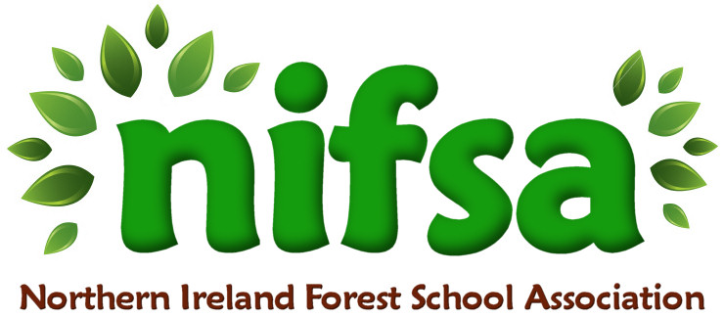

**NIFSA Lesson Plan Template**

Lesson Plan 1: Leaf bingo

|  |  |
| --- | --- |
| **Planning** | |
| **Location** | Nazareth House P.S. |
| **Date** | 26.09.24 |
| **Class** | P3 |
| **Classroom Management** | All 27 of the class attended the Forest school session at the same time. There were 3 adults present with a ratio of 1:9 |
| **Connected Learning/Prior Knowledge** | Children had been learning about signs of autumn and about deciduous and evergreen trees. They went on an autumn walk to identify and learn the names of the local trees the previous week. |
| **Health and Safety** | Risk Assessment Form has already been completed and letter sent out to parents. I have checked the site prior to taking the children there. I will ensure that all children are dressed appropriately for Forest School. I will talk about the rules for walking to our Forest School site in an orderly fashion with the children before we leave the classroom. |
| **Learning Intention** | Children will be able to identify fallen leaves and the trees that the leaves have fallen from within the Forest School boundary. |
| **Success Criteria** | Children will have filled their bingo card.  Children will engage in teamwork. |
| **Resources** | First Aid Kit, whistle, mobile phone |
| **Differentiation/Target Groups** | Three SEN children within the class group were supported by each of the adults, one per group of 9 children. Children worked in small groups of 2/3 along with their adult. |
| **Other** |  |

|  |  |
| --- | --- |
| **Lesson Content** | |
| On Arrival | I gathered the children together to listen to and discuss the need for rules whilst in Forest School. I introduced the rules about the whistle: 1 blow of the whistle = stop and “be a tree”, 2 blows of the whistle = come to me immediately. I reminded them to have fun and enjoy learning in the outdoors. We set out our boundary flags together, ensuring that everyone understood that those flags are to keep us safe and we do not go past them. We have a pond in our Forest School site, so I used cones to place around the perimeter of it whilst highlighting the importance of the danger of water to the children. |
| Activity explained | I discussed our recent Autumn Walk and refreshed the names and shapes of the local trees within our Forest school boundary: Oak/Ask/Sycamore/Horse Chestnut/Beech trees.  I distributed bingo leaf cards and explained how the children needed to collect one of each leaf type to fill their leaf bingo card. |
| Finishing | At the end of the activity, I invited the children to return to me with their filled leaf bingo sheets. I give them opportunities to discuss what they found and to tell us about any other things they observed that is relevant to the task.  Finally, I asked the children to leave no trace before evaluating how they enjoyed the lesson and to ensure that we had collected our boundary flags and our kit bag. |

|  |  |
| --- | --- |
| **Evaluation/Review** | |
| How did the group session go? | The children were very excited to be outside doing a Forest School lesson. They worked very well in their groups and there was a lot of discussion between the children comparing their leaves and helping each other find what they needed. They all followed the rules and stayed safely within the boundary. |
| Focus on individual pupils | SEN children were supported by one adult each and were also able to complete the task with support. |
| What would you change for next time? | I would have a large A2 bingo page for each group rather than lots of small A4 pages as the children could leave it centrally and place their leaves on top of the corresponding leaf rather than carry them all around in their hands. |