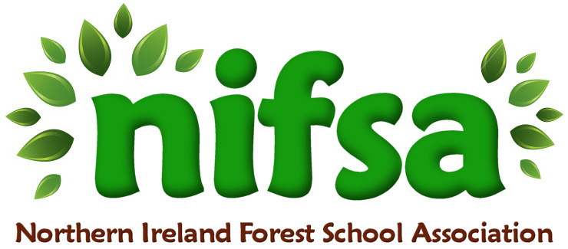
NIFSA Lesson Plan Template

Planning
Location | School field (outdoor classroom area)
Date | November 2025
Class | Nursery
Classroom Management | Members of staff: Miss Hanna (teacher), Miss Milliken (general assistant) Miss McBride (SEN assistant) Harley (NRC student)
Connected Learning/Prior Knowledge | We have been learning about our body parts and naming part our face. The children collected autumn “treasure” in their autumn bags.
Resources needed | Boundary sticks, whistle, wood logs, face cards
Health and Safety | Site and activities fully risk-assessed.
Emergency equipment | First Aid kit

Lesson Content
On Arrival | Welcome everyone  -Practice whistle (2 for freeze, 1 come to me)  -SONG- Head, Shoulders, Knees and Toes  - Simon Says game
Activity explained | Each staff member will take a group of children and they will use the contents of their autumn bags to make autumn faces. They may use the card stimulus provided or create their own.
Finishing | Tidy up- leave no trace.  Children will do a gallery walk of each other’s creations

Evaluation/Review
How did the group session go?
Focus on individual pupils
What would you change for next time?

