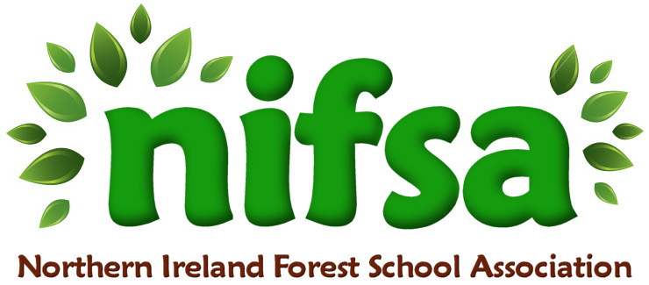
NIFSA Lesson Plan Template

Planning
Location | School field (outdoor classroom area)
Date | September 2025
Class | Nursery
Classroom Management | Members of staff: Miss Hanna (teacher), Miss Milliken (general assistant), Miss Morrow (SEN support assistant for J)
Connected Learning/Prior Knowledge | This is the children’s first “Forest School” session. We have explored the outdoor area during a free play session and are learning the boundaries/rules.  We have been discussing “how old are you”. The children are 3 and 4 years old.
Resources needed | Boundary sticks, whistle, number cards, glue
Health and Safety | Site and activities fully risk-assessed.
Emergency equipment | First Aid kit

Lesson Content
On Arrival | Welcome everyone  -Set out boundaries and reinforce children must stay inside them (discuss pictures on boundaries)  -Practice whistle (2 for freeze, 1 come to me)  -Explain we do not pull from plants that are living  -SONG- Number song
Activity explained | Each child will receive their age printed on to a piece of card. They must go on a hunt to find loose parts (grass, fallen leaves, flowers) to decorate their age. The card will already have glue on it.
Finishing | Art gallery- we will put all our ages on the ground and the children can admire their work.  -Leave no trace

Evaluation/Review
How did the group session go?
Focus on individual pupils
What would you change for next time?

