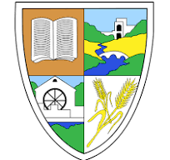
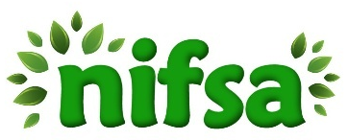
C.P.S Forest School
Lesson Plan

Lesson Focus | Bird Nests
Learning intentions | Children will:  - Explore the outdoor environment using the senses  - Follow agreed safety rules and routines during outdoor learning  - Develop understanding of birds and their basic needs  - Work cooperatively to create a bird nest using natural materials  - Communicate ideas and reflect on learning through discussions
Introduction | - Go on a boundary walk, talk about surroundings using senses  - Have children sitting at firepit  - Remind children of boundaries and forest school rules  - Practice what to do when 1, 2, and 3 whistle blows  - Explain around the firepit that today we are learning about birds and how to make them a nest.  Worms game warm up  Have two teams of children; one team hides the worms (red wool) around the forest and the other team are the birds and must try to find them.
Activities | - Learning about different types of birds, what they eat etc.  - Show them the interactive real call birds.  - Explain that today they are going to make a birds nest for their own bird using natural materials.  - Put children into their mixed ability groups.  - Children in their groups will go and find the different materials for them to use (remind them not to put things into their mouth).  - Once all groups have made their nest have time for each group to ‘Show and tell’ what they have done. Get the other children to tell one thing they liked about someone else’s to encourage peer review.  - Teach children how to tidy up – leave no trace.  - Use evaluation cards from the kit.
Resources | - First aid bag  - Boundary flags  - Whistle  - Emergency folder  - Real call birds  - Red wool worms
Evaluation & Observations
Follow up opportunities | - Get children to research different birds  - Bird spotting worksheet  - Draw along bird videos or on ipads/ just2easy drawing  - Save observation images to app

