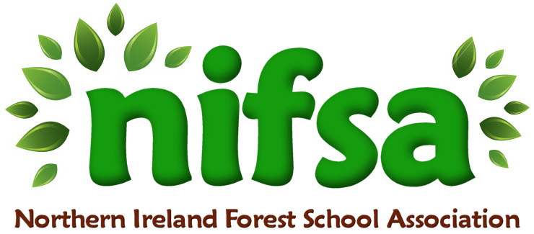
Chalk Hieroglyphics

Planning
Location | School Grounds
Date | 01/26
Class | P5
Classroom Management | Whole class, individual work, pairs
Connected Learning/Prior Knowledge | Our topic in Jan/Feb is Egypt. The children have been reading stories and completing research during World Around Us, Literacy and ICT tasks. They have previously studied the concept of hieroglyphics and made comparisons between the Egyptian alphabet and ours.
Health and Safety | Check area for hazards before session
Learning Intention | Create hieroglyphics in the school grounds using chalk and then allow other groups to find and translate names back into English. Develop skills of cooperation and working with a partner as well as listening to and carrying out instructions.
Success Criteria | The children will be able to create chalk drawings of their names in hieroglyphics which will be deciphered by other groups and translated back into English.
Resources | Boundary markers  Chalk  Copy of corresponding hieroglyphics to English  Pen  Paper  Clipboard
Differentiation/Target Groups | Whole class, pairs
Other

Lesson Content
On Arrival | Forest School rules  Set boundaries
Activity explained | Describe the comparison between Egyptian hieroglyphics and the alphabet, explaining how to crack the code.  Pair up into groups of two.  Give each group chalk for drawing, a clipboard, piece of paper, pen and a code page (converting Egyptian symbols to our alphabet)  Egyptians used different symbols to replace letter which created pictures to describe stories and letters. It was their way of writing.  Give children time to look at hieroglyphic symbols.  Give children time to write their names in hieroglyphics using chalk.  Give children time to walk round each set of images and decipher the hieroglyphics back into English.
Finishing | Leave no trace. Wash the chalk off the playground and collect in all materials  See how many names each group found and translated.  Evaluation happy/sad faces.

Evaluation/Review
How did the group session go? | The children enjoyed this session and worked well within their mixed ability pairs. They enjoyed drawing their names in hieroglyphics and worked well to decipher the different symbols back into English names.
Focus on individual pupils | Pupil K struggled at the start to gain focus, however as the lesson progressed, he worked well with his peer and enjoyed the responsibility of finding the hieroglyphics and being able to crack the codes.
What would you change for next time? | I would perhaps use coloured chalks rather than just while to enhance the drawings and creativity of the task.

