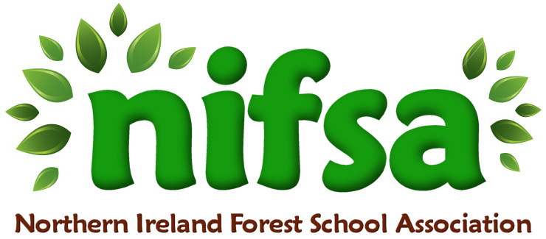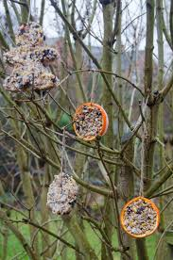
MAKING BIRD FEEDERS

Planning
Location | School Grounds
Date | 03/26
Class | P5
Classroom Management | Whole class, pairs
Connected Learning/Prior Knowledge | Part of WAU topic connected to healthy eating. The children have been reading about healthy eating and the importance of vitamins and minerals. They have learnt that Vitamin C is important for their body (oranges will be hollowed out and kept for break, skins will be used as the outer structure of the bird feeder).
Health and Safety | Check area for hazards before session
Learning Intention | Work in small groups to hollow out oranges, make a mix of bird food and fill the orange skins to make bird feeders. Use string to make a loop in order to attach the bird feeder to a tree.
Success Criteria | The children will work collaboratively to make their own natural bird feeders in groups of 2 or 3.
Resources | Boundary markers  Oranges  Bowls  Bird feed mix and lard  Spoons  String  Scissors and knives  Wipes
Differentiation/Target Groups | Whole class, groups of 2/3
Other

Lesson Content
On Arrival | Forest School rules  Set boundaries
Activity explained | Recap the purpose of healthy eating and compare this to not only our own bodies but the animals around us.  Explain that winter provides less food for animals and that sometimes they need a helping hand.  Say that we are going to use the inside of the oranges for a healthy snack, but that the skin shells will be used to fill with bird food mix and hung on the trees for the birds to eat.  Give children time to hollow out their oranges, to fill the skins with bird food mix and to make a hole in the skin for the string to be put through to create a hanging loop.
Finishing | Leave no trace. Replace all the natural materials and collect in scissors, string, bowls, knives and excess oranges and bird food mix.

Evaluation/Review
How did the group session go? | The children really enjoyed this lesson as they felt they were contributing to their environment and caring for the birds in the area. They enjoyed working outside and were able to have snack time as well.
Focus on individual pupils | The children enjoyed this task and worked well together. K and J were placed with calm children who were able to work well and make the activity a success.
What would you change for next time? | I’d maybe make the holes in the orange skins for the children as this was quite tricky and they needed some adult help. I’d also use two bits of string rather than one, so the orange cups didn’t tip the wrong way when hung on the tree. I brought out wipes, but it would also be good to have a bucket of soapy water.

