Lesson Plan Mrs Moffett
Subject | Topic | Class | Date
Forest School | Measure | P7

Baseline knowledge
The children have recently started weekly Forest School lessons.
The classes have completed maths lessons in measure. There is some confusion in converting mm, cm & m.

Learning Intentions Success Criteria
- To work in a team  - To choose an appropriate way to measure | - Complete the age of a tree task

Resources
iPad  Whistle  Calculators  Pencils | Thumbs up/down  Tape measure  Trundle Wheel  Recording sheets | String  Recording sheets  Metre sticks  Distance cards

Lesson Introduction
Gather the children in a circle. Go over the Forest school rules; 1 whistle = freeze; 2 whistles = to me; learn and have fun.
Set up the boundary makers; field, gates, explain no one past the green shed.
Find someone taller than you – find someone shorter than you – find someone the same height as you.
After a few rounds, double up the groups and give out the estimating measure cards – ask the children to estimate the measurements listed and check their findings using the tape measures, metre sticks or trundle wheel.

Teaching Content
How tall do you think the tree is? How can we measure the trees?
Explain how to use the pencil and buddy method to measure trees -
• The children need to work in pairs or small groups.
• Child 1 stands with their back against the tree trunk (fig.1).
• Child 2 faces their partner, but moves back a distance.
• Child 2 closes one eye and holds a pencil between thumb and first finger, vertically at arm’s length, so that the point is level with the top of the tree, and their thumb is level with the base of the tree.
• Child 2 stays in the same place and turns their hand until the pencil is horizontal, keeping their thumb level with the base of the tree.
• Child 1 walks away from the tree to the side so that they appear to be walking along their partner’s pencil.
• When they reach the end of the pencil, Child 1 should stop (fig.3).
• Now, using a tape measure, Child 2 or another member of the group measures the distance between Child 1 and the tree. This measurement is approximately the same as the height of the tree.
Demonstrate this a few times with volunteers, then ask the children to work in
small groups to estimate and measure the height of a number of trees.
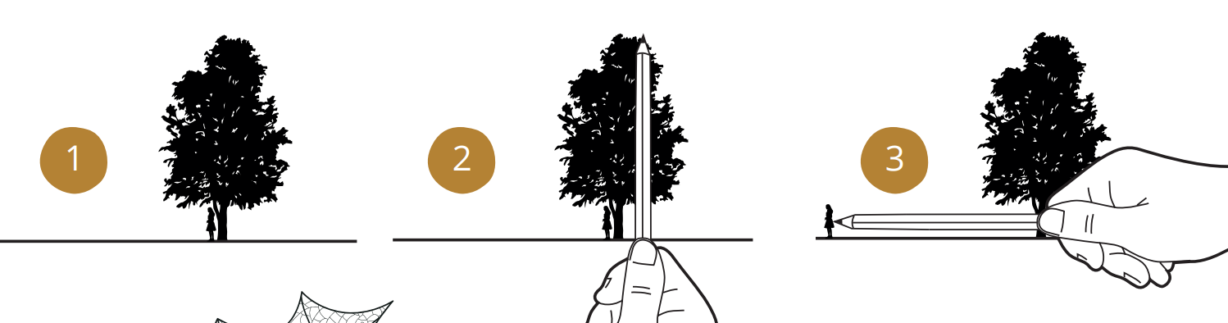

Learning Task (Including Differentiation)
We might know the height but how can we tell the age of a tree?
You can tell how old a tree is by counting the rings on the inside of a trunk after the tree has been felled. Each ring represents a year of its growth.

Without cutting it down we can tell how old the trees are –
1. Divide the children into small groups and give out
one ‘tree age’ sheet to each group.
2. Choose a tree.
3. Estimate (guess) how old it might be.
4. One member of the group measures 1.5 metres up the
trunk (with a tape measure) and another person marks the
spot by putting their finger on it.
5. Someone else uses the tape measure to measure the girth
of the tree in cm (all the way around its trunk) at that height.
6. Now the groups can use a calculator to divide the girth measurement by 2.5
which will give you the approximate age in years.
7. Was the children’s estimation of age anywhere near the actual age?
8. Each group can estimate and measure more trees, seeing if their estimates
get better with practice.

Lesson Conclusion
Bring the groups back together and discuss their findings -
• In which year were the trees planted?
• Are all of the trees in the area the same age?
• Can the children see any trees that are obviously
much younger or older? How can they tell? Thumbs up/down.

Lesson Evaluation

Future Planning

