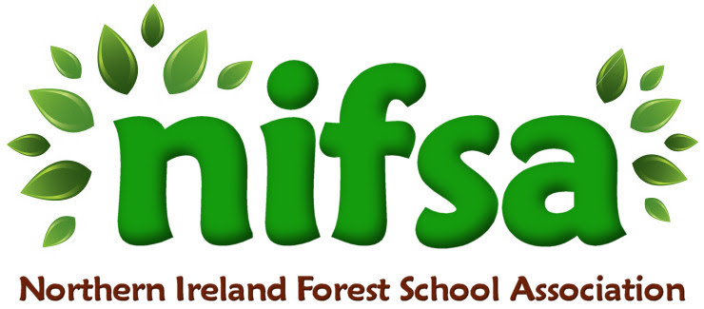
Forest School Awards Application Form

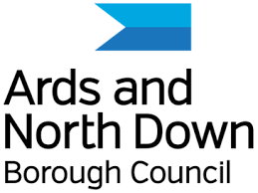

Ards and North Down Borough Council Funded

Section 1: Contact details
Name and address of your school or nursery:

Contact name:
Email address:
Telephone number:
Date:
Academic Year you wish to be considered for:

Section 2: select your Council area
Antrim and Newtownabbey Borough Council ☐
Ards and North Down Borough Council ☐
Armagh City, Banbridge and Craigavon Borough Council ☐
Belfast City Council ☐
Causeway Coast and Glens Borough Council ☐
Derry City and Strabane District Council ☐
Fermanagh and Omagh District Council ☐
Lisburn and Castlereagh City Council ☐
Mid and East Antrim Borough Council ☐
Mid Ulster District Council ☐
Newry, Mourne and Down District Council ☐

Section 2: Project details
- Why does your school/nursery wish to become involved in the Forest
School Awards programme? (No more than 100 words).

- Have you identified the staff member(s) (up to 2 members of staff)? Who are they and what makes them suitable. (No more than 100 words).

- Have you identified the site for your Forest School training? It needs to be within walking distance from your school. Please describe your site. (No more than 100 words). Please upload a picture of the site/park you wish to use.

- Will your Forest School programme be incorporated into your School Development Plan?
Please outline your intentions. (No more than 100 words).

- How will you promote the Forest School programme to the school community. (No more than 100 words).

