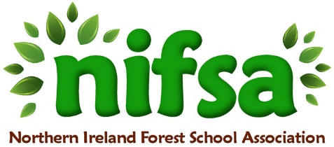
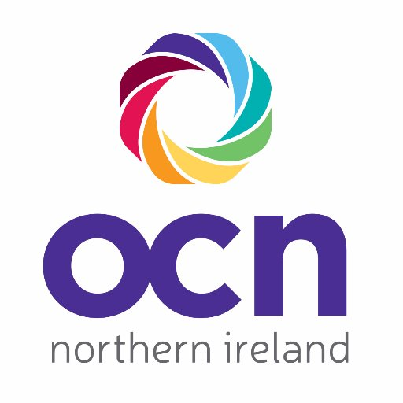

Open College Network NI Registration and Authentication Form

Name: Lynne Gurney

Organisation: King’s Park Primary School, Newtownabbey

Email Address: lgurney792@c2kni.net

Date of Birth: 27-02-84

Qualification Title: Level 3 Forest School Leader

Authentication of Assessment Evidence: Learner Statement
I confirm that the work/evidence I have submitted is my own work and has been created by me. I understand that my results may be invalidated if I have submitted evidence that is not my own work.
Type in your name: Lynne Gurney

Date: 05-01-26

