
Forest School Handbook

King’s Park Primary
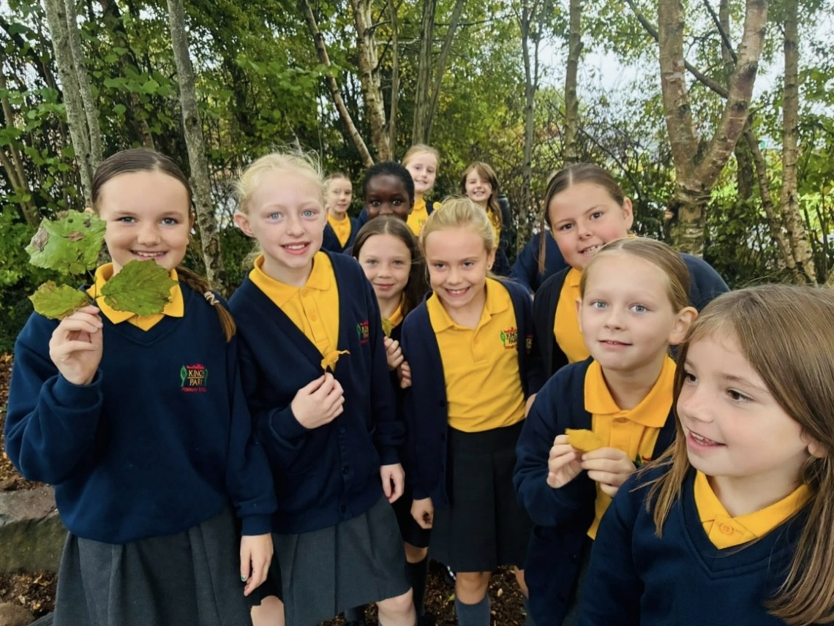

Contents
Page 3 Welcome to Forest School
Page 4 Guidance for Volunteers
Page 5 Emergency Procedure
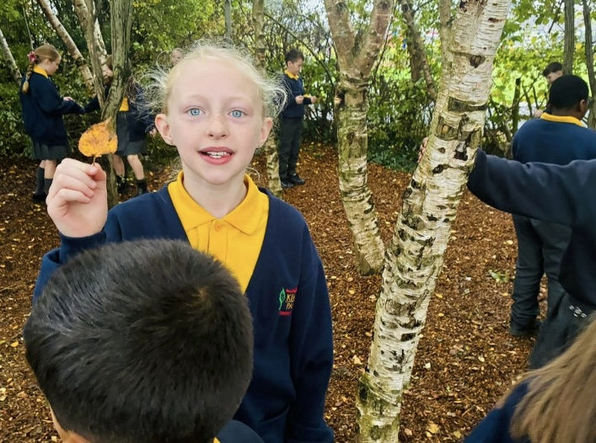
Page 6 Procedure in case of a participant going missing/absconding
Page 7 Health & Safety Policy
Page 8 Site Safety
Page 9 Risk Assessment Policy
Page 9 Staff and Pupil Ratio
Page 10 Behaviour Policy
Page 11 Child Protection Policy
Page 12 Equal Opportunities Policy
Page 13 Equipment – Tools/Forest School Leader’s Equipment
Page 14 Toilet Protocol
Page 14 Insurance
Page 15 Impact of Forest School on the Woodland
Page 16/17 Appendix 1 Risk Assessment Form
Page 18 Contact details

Welcome to Forest School
Forest School is an educational programme developed from Danish ideas of working with children and young people in the outdoors, helping to build self-esteem, social skills and independence. Hands-on activities with natural materials develop practical and intellectual skills, which can be linked to the National Curriculum. Forest School aims to boost confidence through setting students up to succeed. Tasks are broken down into small achievable chunks that are matched to students’ capabilities.
In addition, Forest School helps children become part of an effective efficient team and to participate in a range of creative, sensory and environmental awareness activities.
Forest School uses children’s learning styles as a basis for the presentation of all activities. Children who learn visually can access learning through the demonstrations. All activities are presented through speech for those children who learn aurally. Freedom to touch, feel and “do” satisfies the kinaesthetic learner.
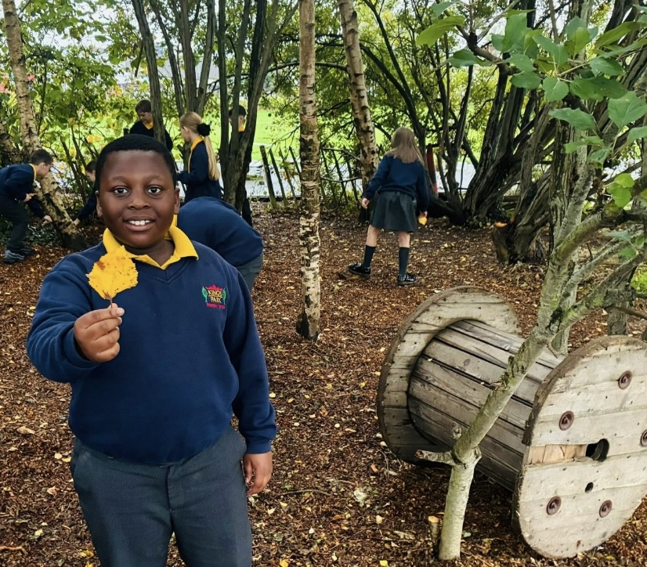
This pack contains information for staff, volunteers and parents of children helping with the Forest School Programme.

Forest School – Guidance for Volunteers
Forest School welcomes the opportunity to work with you. Volunteer adults are vital and essential. Included are some guidelines to make this a valuable experience for all.
Please:
- Ensure that you are appropriately dressed for the weather conditions of the day.
Many Forest School activities involve getting damp and muddy. See clothing list below.
- Inform the team of any medical conditions or allergies that may affect you during the Forest School session.
- Complete the Volunteer Helper Information Form.
- Familiarise yourself with the policies in this handbook.
- Feel free to ask any questions. The Forest School team will be happy to explain the Forest School ethos and aims of each session.
- Maintain confidentiality.
- Assist the leader in helping the children to maintain their own and others’ safety.
- Report accidents, hazards and equipment defects to the leader.
Your co-operation regarding requests and instructions from the Forest School staff is greatly appreciated.
Please note that it is Forest School Policy to carry out an AccessNI Check before you can visit the woodland with the children.

Clothing list
- Waterproof clothing – jacket and trousers
- Woolly hat, or sun hat depending on season
- Gloves
- At least 1 jumper – layers of clothing are useful for regulating body temperature
- Long sleeved top even in summer
- Warm socks in winter
- Wellington boots or walking boots or sturdy trainers with good grips.
NOT ADVISED
- Scarves are not advised at Forest School due to risk of entanglement.
- Shorts are not allowed
- Skirts which cover all the legs are allowed if required for cultural reasons.

Emergency Procedures

All participants will be briefed in what to do in case of emergency. A whistle blast will signal that everyone must stop what they are doing, gather by a member of staff, be silent and await instructions.

Listed below are the procedures that will be adopted in case of emergency or unforeseen circumstances:
In case of injury:
If anyone sustains injury or illness which cannot be treated by first aid on site, and requires removal to hospital or a doctor:-
- If severity requires it, 999 is dialled using the mobile phone carried by the Forest School Leader. The remainder of the group should be contained together away from the incident site and involved in a meaningful static activity.
- One member of staff should meet the ambulance at the main entrance to the school or wood and direct the crew to the incident site.
- In minor cases the Forest School Leader will be responsible for contacting the parent/carer of the casualty so that they can collect the child and drive them to hospital or doctor or home.
- If the latter is not possible, as a last resort the teacher/group leader must use their own car. To members of staff should be in a car which is insured for work purposes.
Please refer to Useful Contact Numbers at the back of this handbook.
Procedure in case of a participant going missing/absconding

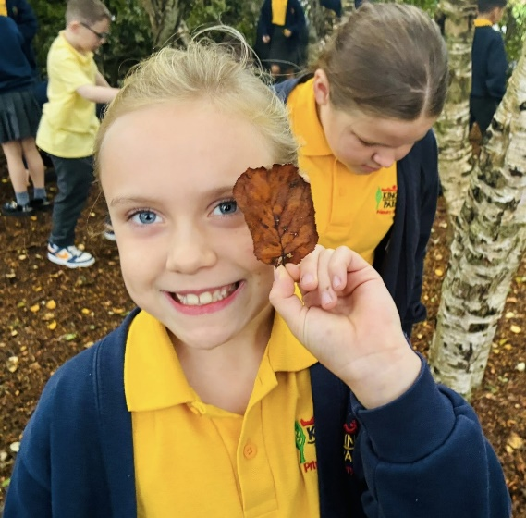

As soon as it is discovered that a child is missing, the situation will be considered an emergency.
- As such, after no more than 5 minutes of calling and cursory looking for the missing person, a detailed adult will contact the school, the police and the child’s contact number.
- Maintaining the correct adult/child ratio, any surplus will be deployed to search for the child.
- The remainder of the group should be contained together away from the last known position and involved in a meaningful static activity.
- Staff should meet and corroborate details of the situation, last known position of the person etc.
- Return to the Last Known Position and mark it immediately.
- All prints found should be marked.
- Do not stand on any prints.
- If the person has not been located the police should be called again and asked to attend the scene. The time when this action is taken will depend on the specific situation and will be judged by the Forest School Leader.
- Whilst waiting for the police to arrive, tracking should continue as before.
- Under no circumstances should other children be used s searchers.
- One member of staff should meet the police at the entrance to the site and direct them to the Last Known Position.
- Staff should then follow the directions of the police Search Advisor.

Health and Safety Policy
The Forest School Leader will endeavour to provide and maintain a safe learning environment and involve all participants in becoming aware of and reporting any potential hazards. Learning about perceived and actual risk is an important aspect of outdoor learning and is incorporated into all activities where practical.
Written risk assessments are undertaken regularly for the areas used for Forest School activities. See Appendix 1.
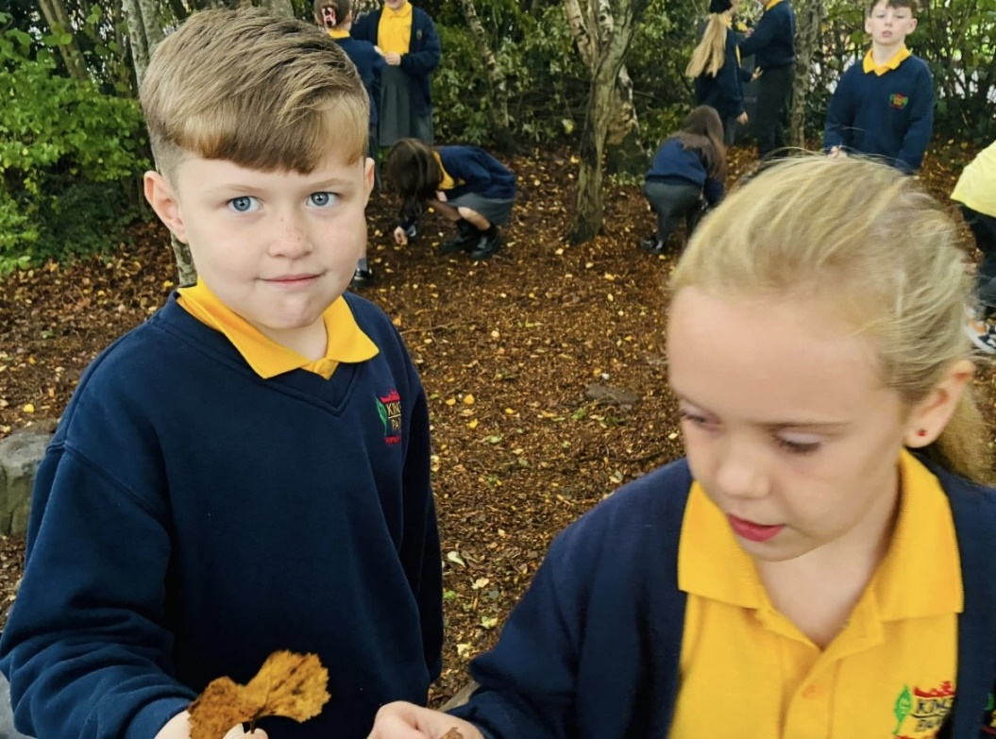
A visual risk assessment will be undertaken prior to each session and any new hazards will be noted on the risk assessment form.
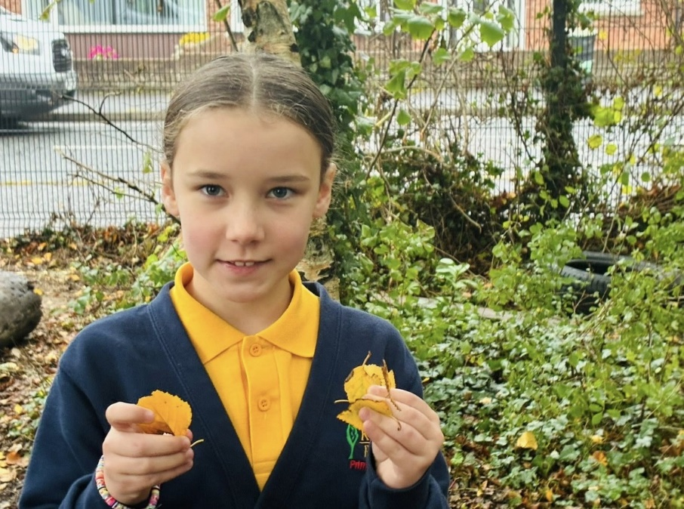
These will be filed and held by the Forest School leaders.
Procedures for emergency situations are included in this file. Please familiarise yourself with these before participating in a session.
The Forest School Team will
- Teach children and adults to maintain their own and others’ safety, involving them in risk assessments and safe inspections.
- Maintain the legal adult:child ratio.
- Ensure equipment meets required standards and is maintained and used appropriately.
- Assume responsibility for the maintenance of the First Aid Kit and other safety equipment.
- Record any incident involving an injury, missing person or allegation of misconduct as soon as possible after an event.
- Regularly monitor the effectiveness of policies and working practices, revising and amending as necessary.
The children, to the best of their capabilities, will:
- Exercise personal responsibility for the safety of themselves and others.
- Observe the safety information with which they have been provided.
A copy of the school’s Health & Safety Policy can be found in the Principal’s office.

Site Safety
The following checks and precautions will be carried out in order to ensure safety at the Forest School site.
- Pre-visit checks will be carried out to ensure the site is free of dangerous litter, refuse, dog and cat excrement, also that there is no damage from fallen trees of hung up branches.
- A session may be cancelled if, in the opinion of the Forest School Leader, weather conditions, such as high winds make visits to the forest unsafe or, if due to staff absence, the appropriate ratios cannot be maintained.
- During very wet weather a shelter will be put up on the school site.
- A risk assessment is carried out for all activities. See Appendix 1.
- All participants will have access to drinking water during sessions.
- During some sessions food may be cooked on a campfire and eaten. Basic hygiene standards will be followed such as cleaning hands before food and using food within sell-by dates.
- During some sessions a fire will be lit using a pre-prepared fire pit. The children are gradually introduced to and taught valuable skills regarding fire safety. They are shown how to approach a fire carefully and how to treat it with respect. They are shown how to put the fire out at the end of the session.

Risk Assessment Policy
The safety of all children is paramount. In order to achieve this, the Forest School leader will:
- Recognise that a hazard is anything with the potential to cause injury or harm.

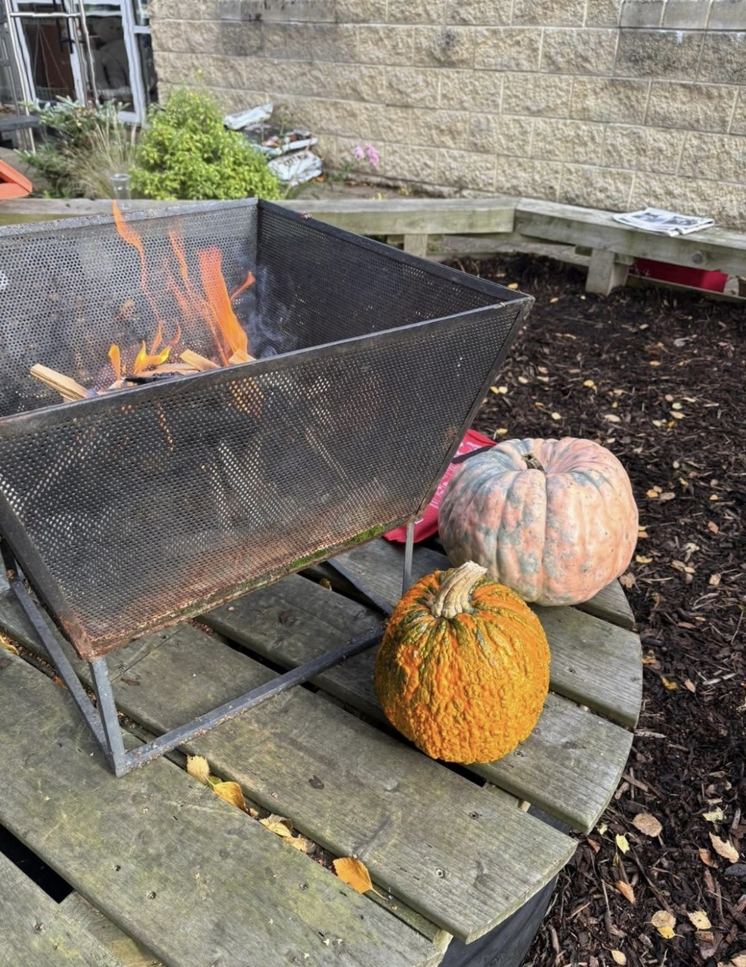

- Identify significant hazards and ensure risks are minimised, taking appropriate action as necessary.
- Carry out regular and continuous risk assessments of working areas. See Appendix 1.
- Be constantly alert to potential, previously unidentified risks.
- Complete risk assessment paperwork.
- Inform staff, volunteers and children of potential risks and methods to minimise them.
- Involve staff, volunteers and children in risk assessment, as appropriate, as part of learning.
- Ensure legal guidelines regarding off-site activities, such as adequate insurance, permission and records are met.
- Implement emergency procedures as necessary.

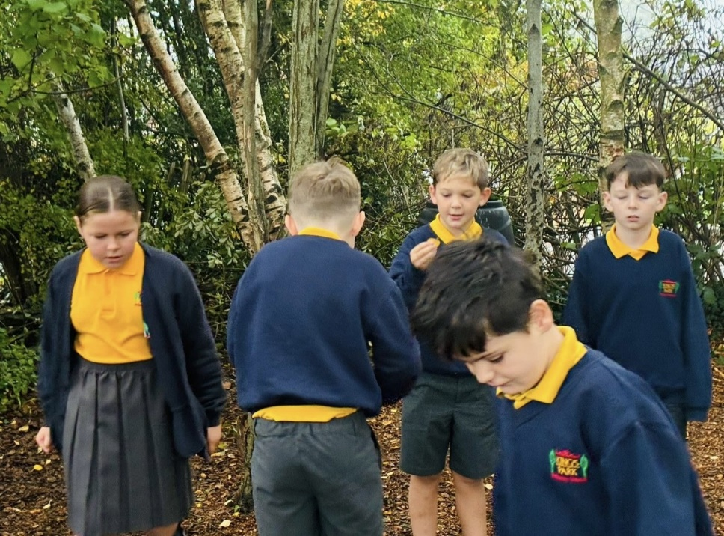
Staff and Pupil Ratios
Due to the nature of Forest School activities, high ratios of adults to children are necessary in order to ensure a safe, high quality learning environment at all times. The minimum ratio of adults to children is 1:6. This means at least two adults with training or experience of teaching/working with young people, for a group of ten children. This ratio will need to be increased if any of the children have special needs that require extra attention.
If the group is working with tools or fire the minimum ratio is 1 adult to 3 children.

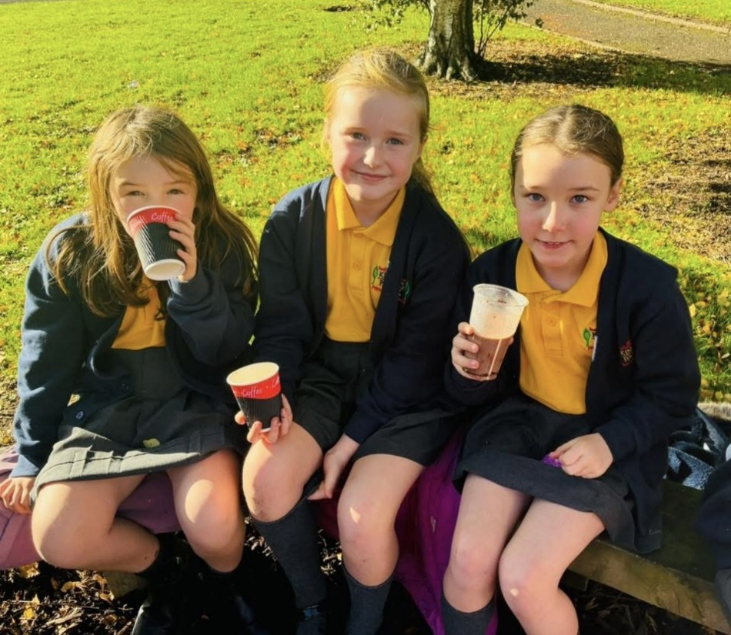

Behaviour Policy
Forest School aims to facilitate children’s self-esteem, independence and motivation to learn, while always maintaining a safe environment. In order that these goals are worked towards, certain standards of behaviour need to be sustained and reinforced. This policy clarifies responsibilities in this area:
The adults at Forest School will:
- Create a positive environment which encourages and reinforces caring, nurturing and acceptable behaviour towards each other, the environment and the equipment.
- Build effective relationships in which all are accepted, valued and treated equally.
- Be consistently mindful of the need to maintain safety.
- Clearly define and reinforce acceptable standards of behaviour.
- Respond consistently to both positive and negative behaviours.
- Consistently model high standards of behaviour.
- Place the needs of the children at the centre of the curriculum to minimise failure and maximise success.
The children, to the best of their capabilities will:
- Respond to requests, instructions or actions, particularly those concerning safety.
- Develop and maintain an acceptable attitude to each other, the environment and the equipment.
It may be necessary, after all possible avenues have been investigated, to exclude a child who is judged to persistently be compromising their own safety and the safety of other children and adults participating in the Forest School programme.
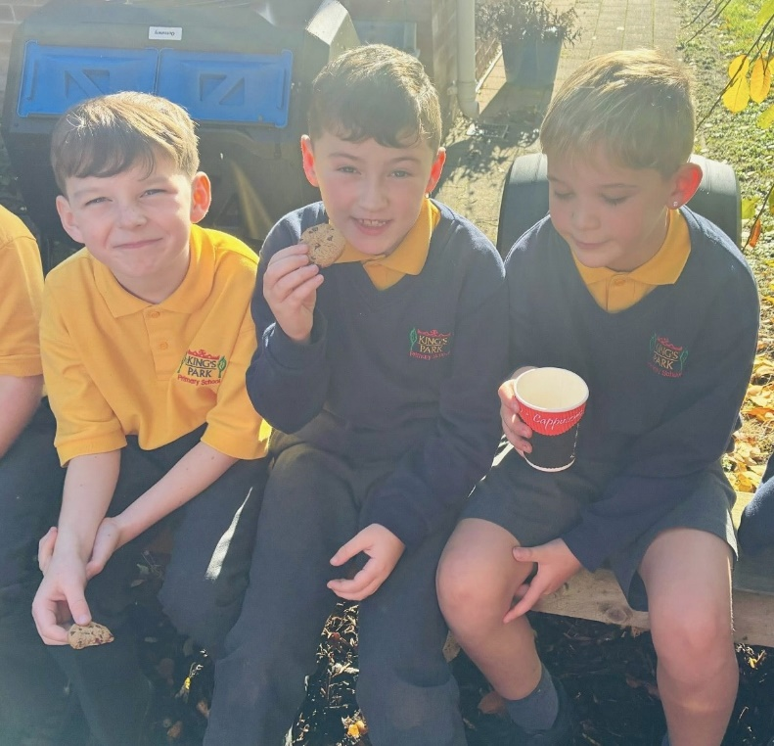

Child Protection Policy
The Forest School team fully recognises its responsibilities for child protection.
Our policy applies to all staff and volunteers working at Forest School. There are four main elements to our policy:
- Ensuring we practice safe recruitment in checking the suitability of staff and volunteers to work with children.
- Raising awareness of the child protection issues and equipping children with the skills needed to keep them safe.
- Developing and then implementing procedures for identifying and reporting cases, or suspected cases, of abuse.
- Establishing a safe environment in which children can learn and develop.
We recognise that because of the regular contact with children, staff are well placed to observe the outward signs of abuse. We will therefore:
- Establish and maintain and environment where children feel secure, are encouraged to talk, and are listened to.
- Ensure children know that there are adults at Forest School whom they can approach if they are worried.
- Include opportunities in the programme for children to develop the skills they need to stay safe.
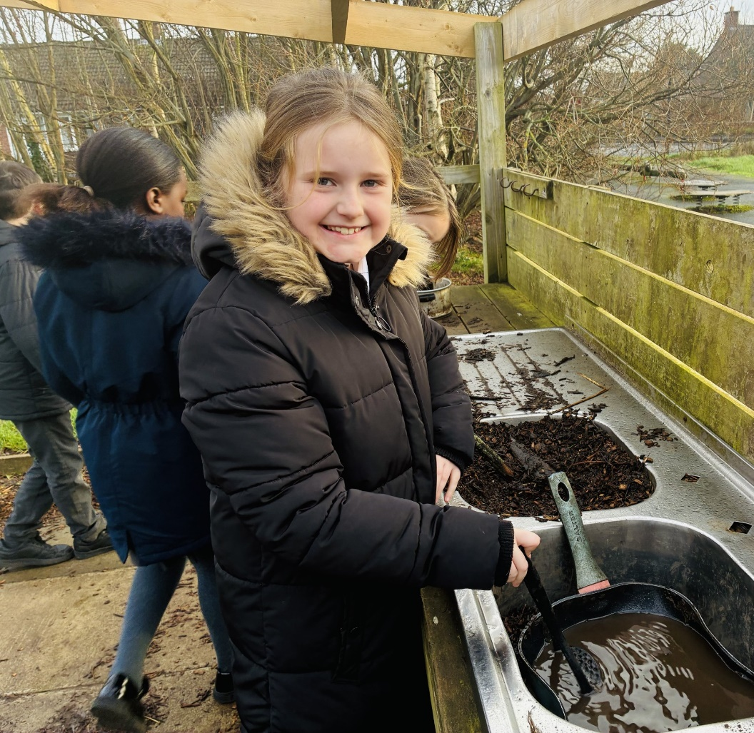

Equal Opportunities Policy
Forest School aims to provide for all pupils regardless of gender, race, ethnicity, religion or disability.
- Promoting a positive, empathetic and valuing ethos.
- Understanding that children have different learning styles and multiple intelligences and striving to accommodate all.
- Working hard to include all, using available resources and seeking expert help and advice as necessary.
- Challenging stereotypical and prejudicial comments or behaviours.
- Supporting those children who experience discrimination and those who, through misguided judgements, discriminate.
- Using opportunities to celebrate the diversity of cultures.
- Exploring opportunities throughout the curriculum to address discriminatory and equality issues.
- Value and celebrate the contributions of all.
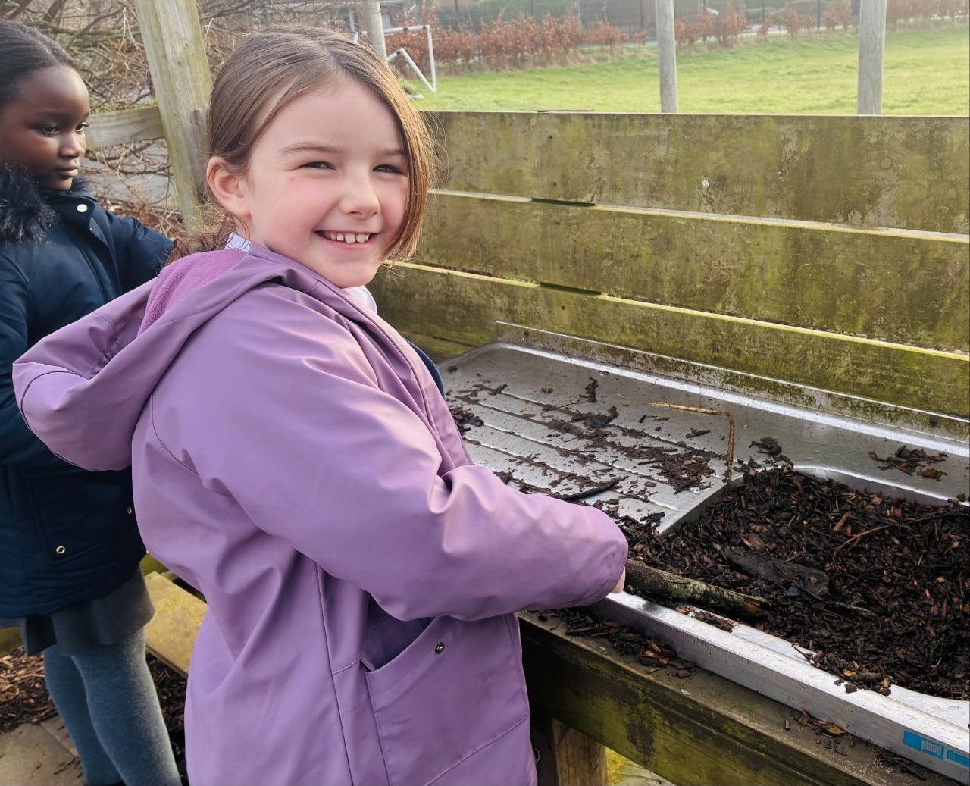

Equipment
Tools
Tools are to be maintained in good order by the Forest School Leaders and inspected before each session to ensure safety.
It is important that during a session all tools are handled properly and treated with respect. To ensure that this happens the following rules should be followed:
- No children should bring any edged tool to any Forest School session.
- No children are allowed to get any tools from the tool box or bag. They must find a member of the Forest School staff to hand them a tool.
- Penknives are to be opened and closed by members of Forest School staff.
- Running with tools is not allowed.
- When walking with tools, saws should be held facing downwards and knives with the blades closed.
- Children may lose permission to use tools if they are misusing a tool.
- All tools need to be counted back into the tool box/bags at the end of each session.

Working with tools:
- When working with penknives, saws, secateurs and billhooks the adult:child ratio should be 1:1.
- Long hair or loose clothing should be tucked away.
- Peelers + knives – always whittle to the side of and downwards away from the body.
- Billhooks – are to be used as cleaving rather than chopping tools i.e. they should not be swung and should never be used with gloved hands.
- Bow saws should have their guards on when not in use.
- Extreme care should be taken that no tool is used to point with.
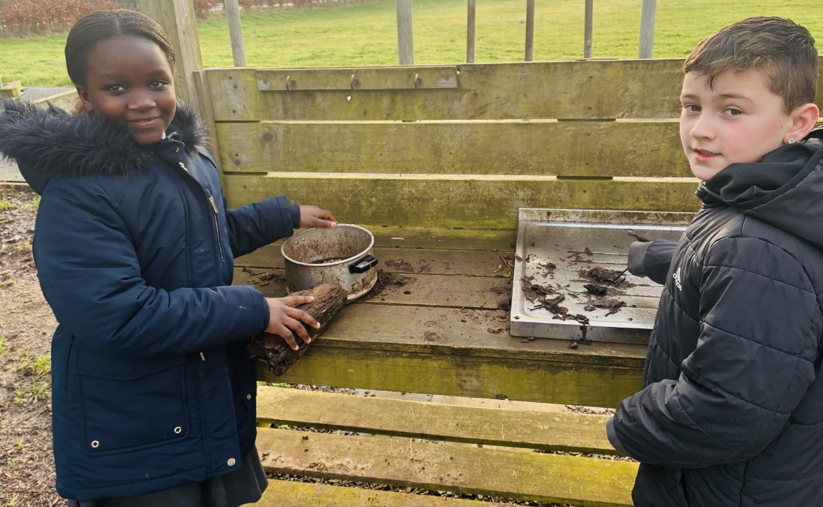
Forest School Leader’s Equipment
- Plastic bags
- Toilet paper
- Hand sanitiser
- Trowel
- Register of children
- Medical details
- Accident forms
- Emergency contact numbers
- Whistle
- First Aid kit
- Fire lighting kit
- Mobile phone
- Equipment required for Forest School activities e.g. wool, bamboo canes etc.

Toilet Protocol
As a volunteer please DO NOT take a child to the toilet. If the child needs help with this they are only allowed to be accompanied by their school teacher, teaching assistant, Forest School Leader or parent who will:
First choice: Visit a toilet which is nearby.
Second choice: If no toilet is nearby
- Take the trowel and toilet paper and find a secluded area out of the site, outside the boundary for activities.
- Dig a hole about 30cms deep.
- Deposit in the hole (including any loo paper used) and cover with a handful of leaf litter. Fill in the hole with the soil removed at the beginning.
- Wash/sanitise hands.

Insurance
The school/youth organisation need to ensure that their own insurance covers them for visiting the woodland and undertaking Forest School activities.

Impact of Forest School on the Woodland
All adults should be mindful of the impact that Forest School has on the woodland. On the school site the following measures are in place to minimise the impact.
- Designated fire pits
- Children are encouraged to stay on the paths for most activities.
Please follow the “Leave no Trace” principles – www.lnt.org/programs/principles.php
When using the woodland, adults and children should be mindful of the impact of lots of feet on the woodland floor, especially on the steeper slopes.
At certain times of the year it may be advisable to avoid certain areas.
The site is rested during the school holidays as Forest School only takes place during the term time.

Appendix 1
RISK ASSESMENT FORM
King’s Park Primary School
Antrim and Newtownabbey Borough Council
Hazard | Assessed by/on | Level of Risk | Short Term Action | Long Term Action
Stinging nettles | KS2 Team  Jan 2026 | L | Teach children what they look like and tell them to avoid. | Teach children what they look like and tell them to avoid.
Brambles | KS2 Team  Jan 2026 | L | Teach children what they look like and tell them to avoid. | Teach children what they look like and tell them to avoid.
Spiky rose bushes | KS2 Team  Jan 2026 | L | Teach children what they look like and tell them to avoid. | Teach children what they look like and tell them to avoid.
Ivy | KS2 Team  Jan 2026 | L | Teach children what they look like and tell them to avoid. | Teach children what they look like and tell them to avoid.
Fungi | KS2 Team  Jan 2026 | L | Teach children what they look like and tell them to avoid. | Teach children what they look like and tell them to avoid.
Groundsman mowing/strimming | KS2 Team  Jan 2026 | L | Keep away | Keep away
Visiting cats/dogs etc. | KS2 Team  Jan 2026 | L | Remove faeces from areas where children are working | Remove faeces from areas where children are working
Litter | KS2 Team  Jan 2026 | L | Remove by FS Team prior to session. Advise to avoid. | Remove by FS Team prior to session. Advise to avoid.
Low branches | KS2 Team  Jan 2026 | L | Vigilance, verbal instruction to children | Remove sharp branches
Road | KS2 Team  Jan 2026 | L | Remind children of boundaries.  Correct ratios.  High visibility vests for adults | Remind children of boundaries.  Correct ratios.  High visibility vests for adults
Steep slopes | KS2 Team  Jan 2026 | L | Instruct children  Position adult nearby | Instruct children  Position adult nearby
Rabbit holes | KS2 Team  Jan 2026 | L | Instruct children  Position adult nearby | Instruct children  Position adult nearby
Uneven/slippery ground | KS2 Team  Jan 2026 | L | Instruct children  Position adult nearby | Instruct children  Position adult nearby
Puddles (muddy water in eyes) | KS2 Team  Jan 2026 | L | Instruct children  Care when splashing | Instruct children  Care when splashing
Antisocial behaviour | Instruct children of danger. Ensure boundaries are positioned. Tape off area if required. | H | Children should be removed from the Forest School site and returned to school if there are any instances of antisocial behaviour nearby. | Children should be removed from the Forest School site and returned to school if there are any instances of antisocial behaviour nearby.

Contact Number Sheet
Please keep this sheet updated and take out for every Forest School session)

King’s Park Primary School Details
King’s Park Primary School General Number – 028 9036 5132
Principal Mobile – 07877 322 129
Vice Principal Mobile – 07734 970 530
Forest School Co-Ordinator – Lynne Gurney
Forest School Teacher Mobile – 07752164926
Forest School Classroom Assistant Mobile – 07516243604
Northern Ireland Forest School Association Details
Forest School Leader – Brian Poots – 07790884522
Accident & Emergency Details –
Nearest Accident & Emergency Hospital – Antrim Area Hospital 028 9442 4000
Site Details –
Antrim & Newtownabbey Borough Council – Biodiversity Officer – Lindsay Matthews – 028 9446 3113
Antrim & Newtownabbey Borough Council – General Number – 0300 1234568
